Instructions on how to deploy a Kares model in ML repository

– Data Science Experience Local

1. Create a new project and from loading the zip file
2. Run the notebook – StockPre. Two Kares deep learning models will be saved in the ML repository
3. Model deployment – Batch Scoring

Since Kares model are taking ‘numpy array’ for input data, but DSX will take in the data as data frame as default. We have to make sure that using array for **both batch scoring** and **evaluation**.

When deploying, click the model ‘StockPrice’ and then go into ‘Batch Scoring’

1. Input data set: scoring.csv (this data set contains data that should be scored)
2. Output data set: output.csv. The output data name can be selfdefined. Make sure to provide ‘.csv’ extension – otherwise you won’t be able to preview and download the output.

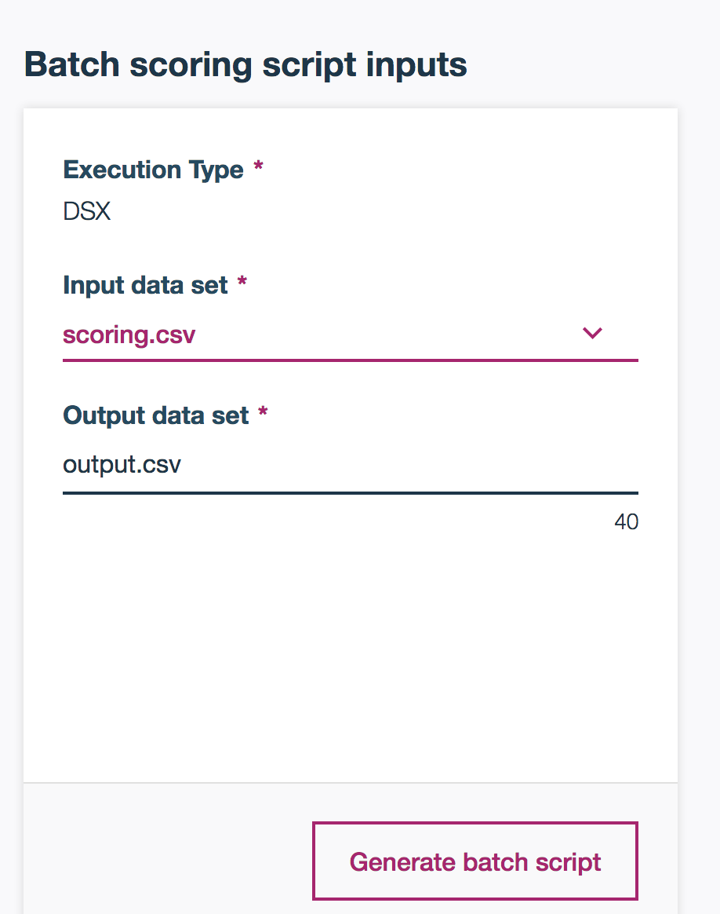

1. Click on **Advanced Settings** and change the file name to StockPredict. Also you could change the file into ‘.ipynb’. This can make sure that you could check the python script for the scoring. Click **Save**.

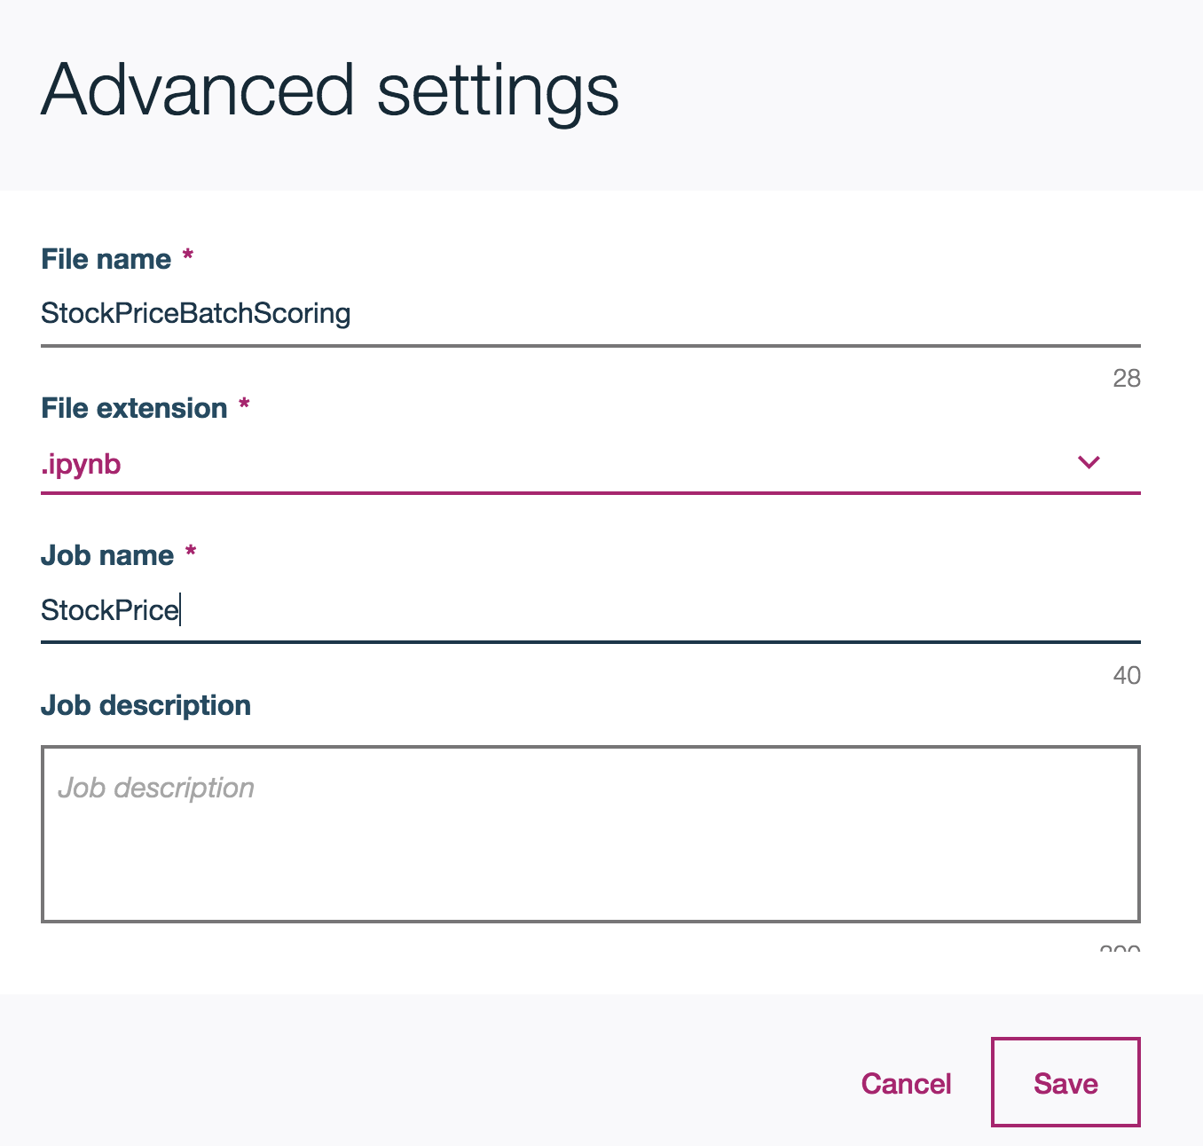

1. Click **Generate Batch Script**. In the ‘Result’ window, you could see the python code that will run to do the batch scoring. We need to convert the input Dataframe into a Numpy Array. So in this example, find the script that read the input_data (line 40). Then add another line after that to convert it into a Numpy Array and make sure that the first column is not read.

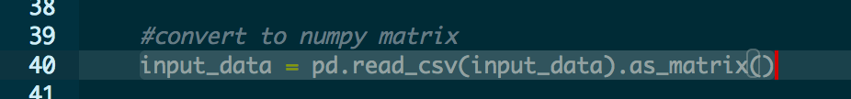

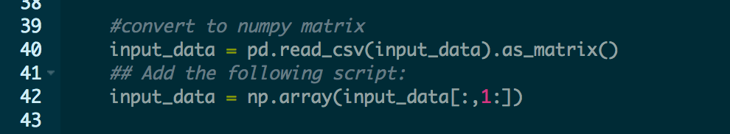

1. **Run now** and wait till the status changes to Success.
2. Model deployment – Evaluation

When deploying, click the model ‘StockPrice’ and then go into ‘Evaluation’

1. Select the data source for evaluation (StockPriceEval.csv file which we generated in a notebook)
2. Pick the evaluation matric, here we choose the ‘Explained Variance Score’ and you can define your own threshold.

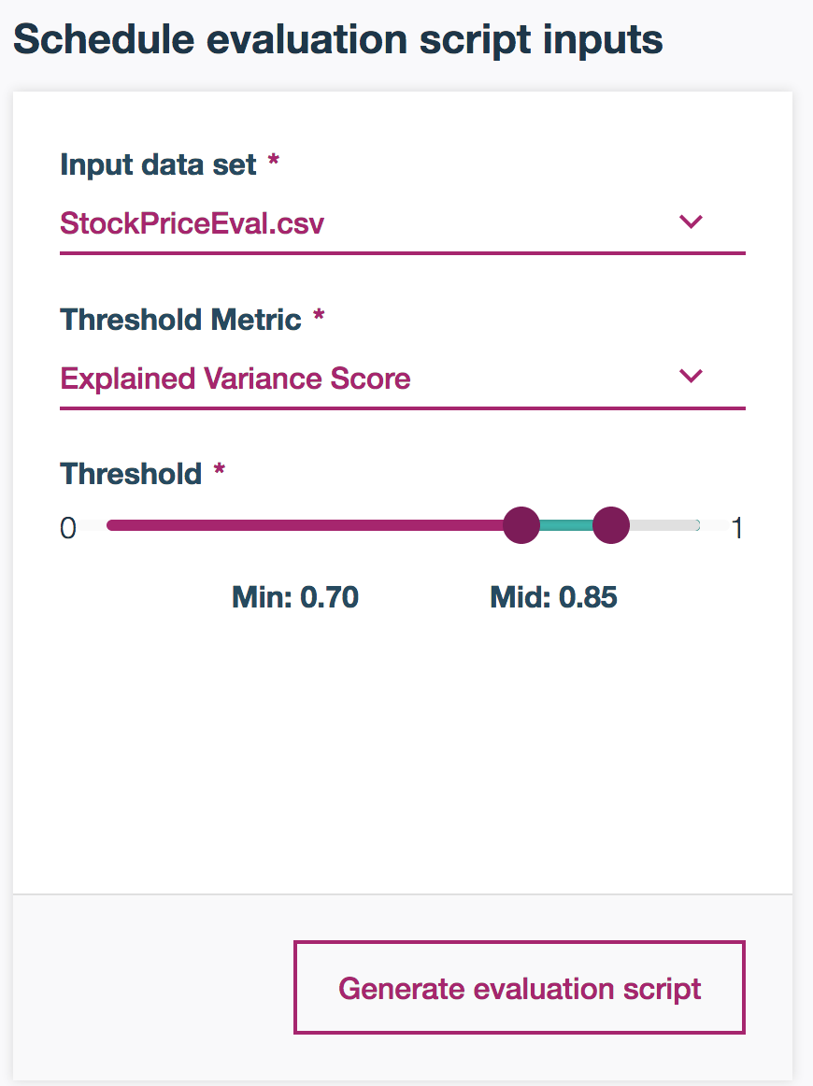

1. Click on Advanced Settings and change the file name to: StockPriceEvaluation. Also you could change the file into ‘.ipynb’. This can make sure that you could check the python script for the scoring. Click Save.

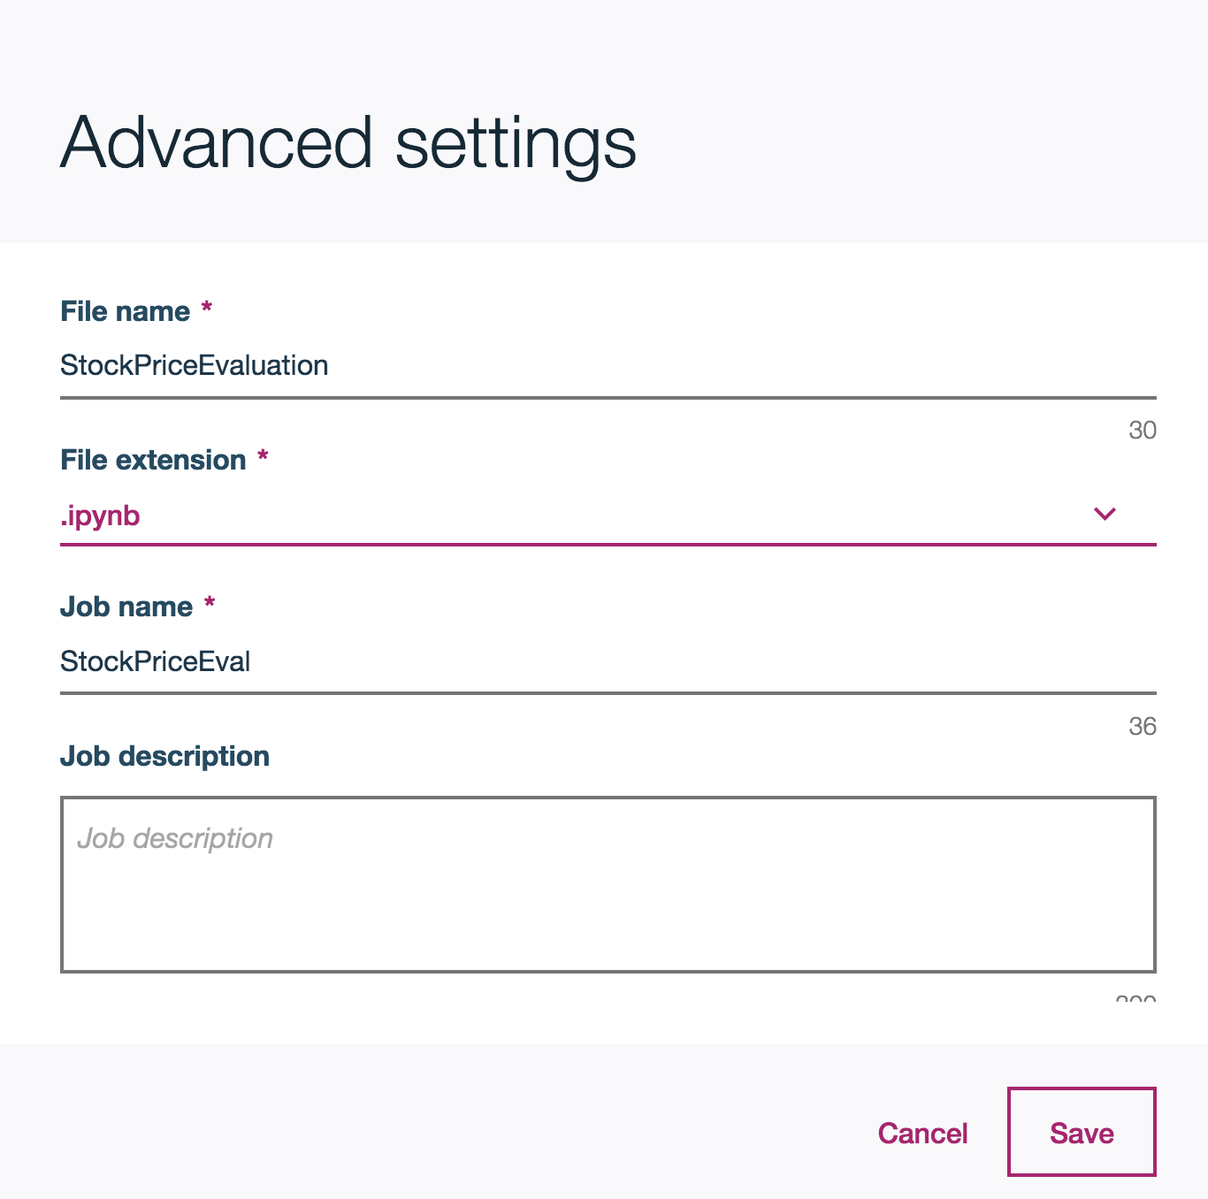

1. Click **Generate Batch Script**. In the ‘Result’ window, you could see the python code that will do the evaluation. We need to convert the input from a Dataframe into a Numpy Array. So in this example, find the script that read the input data (line 30). Then add another line after to convert it into a Numpy Array. In addition, due to the processing python is reading the input data, it automatically detects the column name as number, however they should be read as characters. So do the following edit to the script:

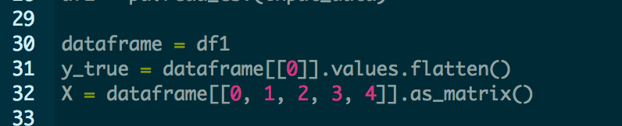

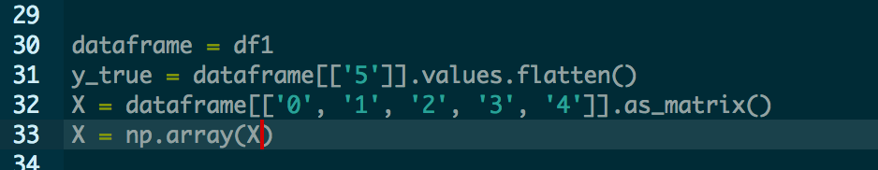

1. **Run now** and wait till the status changes to Success.